C:\Users\user\Desktop\Rcrust Website\Logos\Logo_lowers_large_fullcolour_Rcrust.tif

Phase stabilities with path-dependence

*Version 1 March 2019 (for help contact mjmayne@outlook.com)*

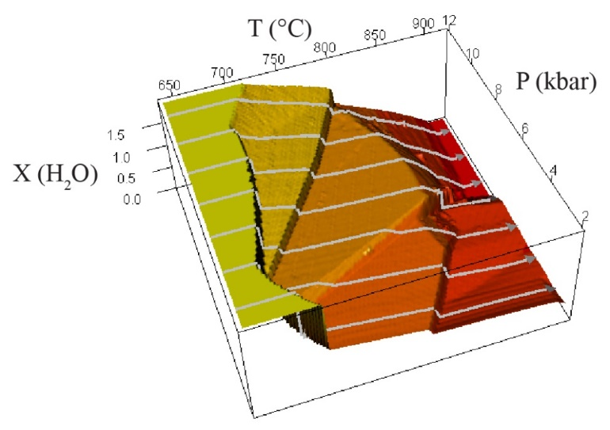

Getting started

Installation 2

Concept 4

Example1 – Simple 6

Example2 – Phase extraction 10

Example3 – Multi-path functionality 13

Reference manual

Rcrust file management 15

List of Parameters 16

Useful functions 24

Development 25

Troubleshooting 26

References 26

GETTING STARTED

Installation

Rcrust was developed using version 3.3.0 (2016-05-03) of R. Copyright © 2016 the R Foundation for Statistical Computing. To install Rcrust perform the following steps:

1. Copy the Rcrust folder to a location of your choice (preferably a root directory for example C:\ or D:\). The result should be similar to the picture below with all the Rcrust files contained in single directory for example D:\\Rcrust\

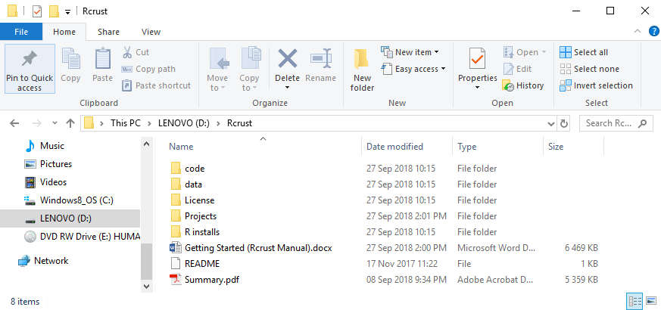

**2**

**1**

**Figure 1 - Rcrust file structure located in the root directory D:\\Rcrust\**

1. Install a working version of R on your system (at least version 3.3.0). The latest version of R used in the development of Rcrust is located in the folder “R installs” for your convenience. **Warning:** Rcrust requires the **64 bit** version of R. When installing R please ensure “64-bit Files” is ticked.

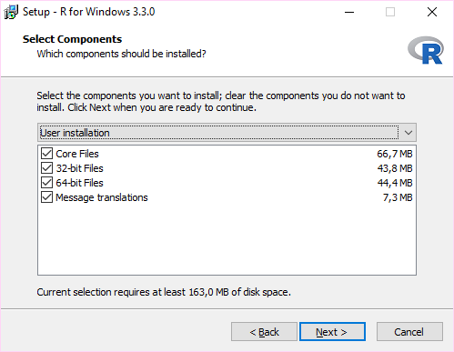

Figure 2 - R installation instruction ensuring at least "64-bit Files" is ticked

\*Alternatively newer versions of R (which may not be compatible with Rcrust) can be downloaded from <http://www.r-project.org/> or for windows can be found directly at <http://cran.r-project.org/bin/windows/base/>

1. Open the folder called code in the Rcrust folder.

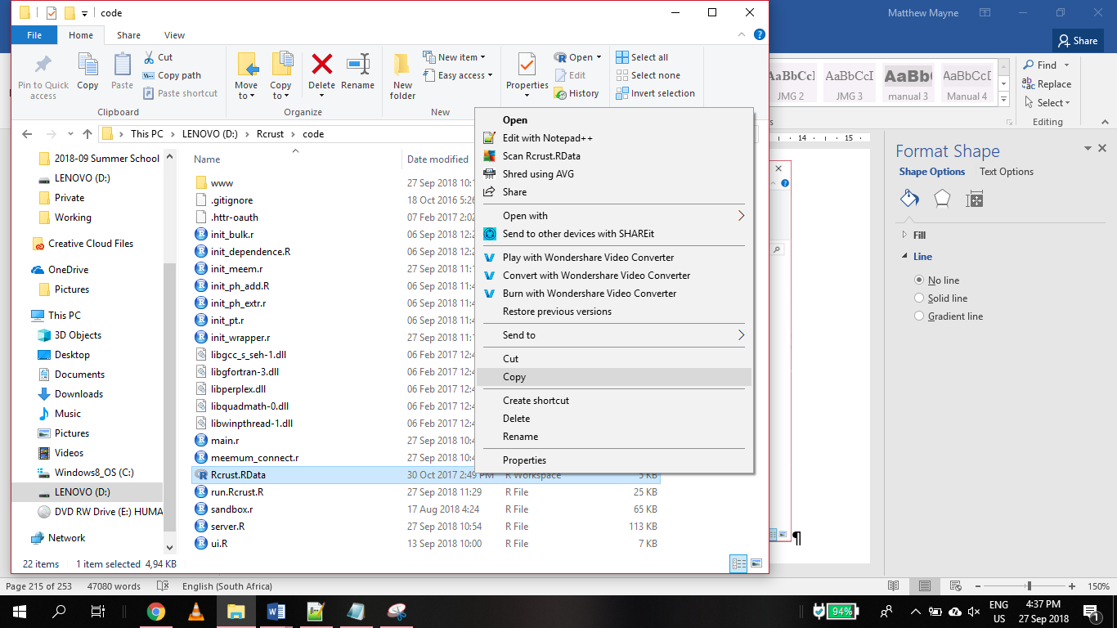

**4**

**3**

**Figure 3 – Rcrust file (circled in red) within code folder. The Rcrust file location here is D:\\Rcrust\code\Rcrust.RData**

1. Copy the Rcrust file found in the code folder (~/Rcrust/code/Rcrust.RData). This can be done by right clicking on the file (circled in red above) and selecting “Copy” or by selecting the file and pressing “Ctrl”+”c”.
2. Paste the Rcrust file as a **shortcut** on the Desktop. This can be done by right clicking on the Desktop and selecting “**Paste shortcut**”.

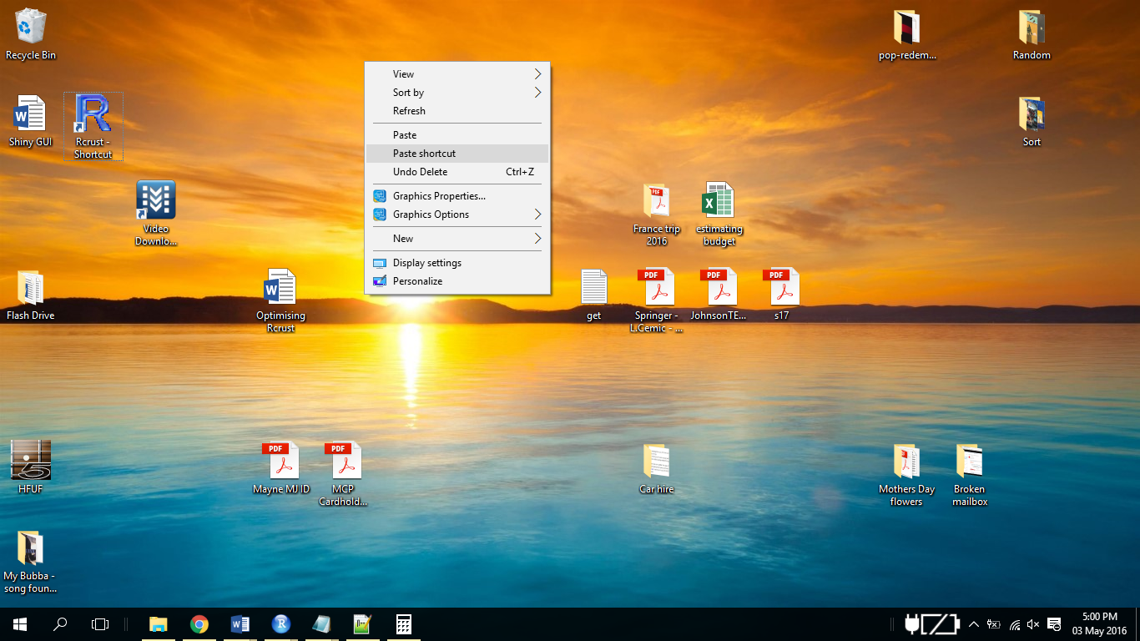

**5**

**Figure 4 – Paste shortcut option selected for Rcrust file**

1. Rename this file to “Rcrust”. Double click on this shortcut to open Rcrust.
2. Rcrust requires the R package called “shiny”, If this is not installed on your computer when you open Rcrust, Rcrust will try to install it (this requires an internet connection). Follow the prompts to complete installation of the package (it may ask you if you wish to create a personal library – choose yes). Alternatively, shiny can be downloaded here: <http://shiny.rstudio.com/> .

Each new project will be automatically saved in the “Projects” folder along with its associated inputs and outputs. To load a previously saved project simply double click the “xxx.RData” file in the associated project folder or open Rcrust from the desktop shortcut and load the project via the Rcrust GUI.

Concept

Rcrust is an R program aimed at modelling with path dependence. The program functions by calculating a number of points in P-T-X space where a bulk composition is passed between points. This creates path dependence as points within the path rely on the outcomes of previous points for their calculation. The bulk composition can be altered at each point by phase manipulations consisting of phase additions and/or phase extractions. Phase stabilities for each point are calculated by using a compiled form of Perple\_X (Connolly & Kerrick, 1987; Connolly, 2005, 2009).

Rcrust manages calculations by splitting the full thermodynamic system (FS) into 3 subsystems: The reactive subsystem (RS) which contains the phases in thermodynamic equilibrium; The addition subsystem (AS) where phases are waiting to be added to the reactive subsystem; and the extract subsystem (ES) where phases extracted from the reactive subsystem are stored. The reactive subsystem is in thermodynamic equilibrium with the P-T-X conditions of each point and is re-equilibrated after each P-T-X change. The addition and extract subsystems are in thermodynamic isolation from other subsystems and from the P-T-X conditions of each point.

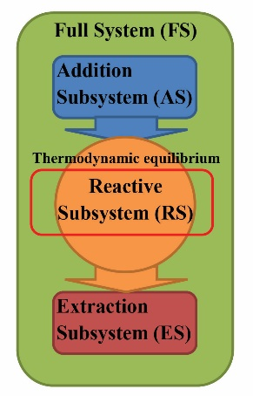 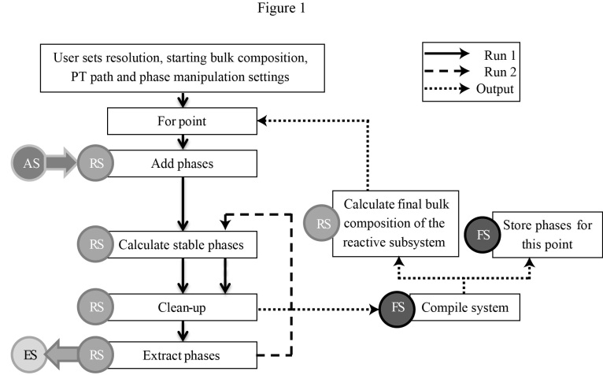

**Figure 5 - Relationships between systems (left) and flow chart (right) illustrating the Rcrust program structure for a single path. The user inputs the calculation’s resolution, starting bulk composition, P-T path and phase manipulation settings. Each step in a path consists of two runs and an output. The first run is shown in a solid line, the second run in a dashed line and the outputs in a dotted line. Circles show the system or subsystem involved in each step as AS (addition subsystem), ES (extract subsystem), FS (full system) or RS (reactive subsystem). Arrows show interactions between systems. From** (Mayne et al., 2016)

Parameters for calculations are accessible to the user via the Rcrust Graphical User Interface (GUI). This GUI writes data to a text file which is then input to the program thus allowing the user to edit the file ‘behind’ the GUI as well as save inputs for re-use. The code files are extensively commented, and described in this document. The calculations routines are defined in several files, written in a modular way that should allow easy addition of features if required. For example, the Phase Extraction routine has been modified to suit the needs of magma extraction where additional capabilities allow melt extraction to leave a set melt retention amount behind.

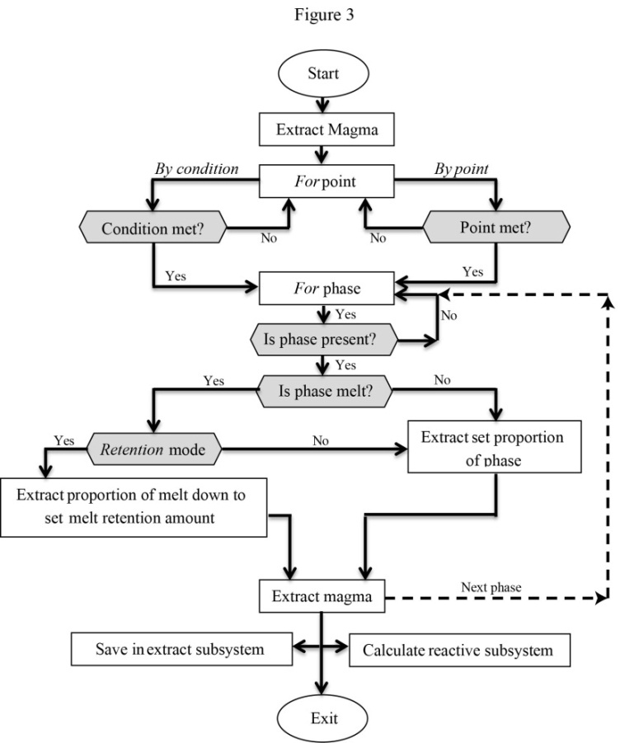

**Figure 6 - Flow chart of the magma extraction routine. Grey hexagon shaped boxes are decision points. Coding variables are in italics. The for phase loop (dotted line) is repeated until each phase tagged for extraction has been considered. If Retention mode is active melt is considered last so that other phases extracted are accounted for in its calculation. From** (Mayne et al., 2016)

Rcrust results should easily be loaded into GCDkit and examined from there.

It is important to remember a few things:

* Rcrust is in development. It is not mature software. It is very unstable at the best of times, and very unforgiving in terms of improperly formatted inputs, etc. When Rcrust fails, it will try to generate some human-readable error messages: read them! It may well give you hints at things you can correct in your inputs.
* Most of the errors you will see are related to incorrect input (files with incorrect number of lines etc.); or to exotic phases being produced by meemum.

Rcrust calls a set of binary files containing the thermodynamic equations thus relying on published databases (Holland and Powell typically). The output will never be better than the underlying thermodynamic model. Since we focus on melting, we are tied to the capacities (and limitations) of the melt models. For example, melt(HP) does not include Titanium therefore its use in a system containing Ti can over/under estimate melt abundance.

Examples

Below are 3 example simulations to get you started using Rcrust. All you need to do to complete the examples is to perform the actions written in bold numbered text. Explanations of what these actions achieve are given between steps.

Example1 – Simple

**Follow the bold numbered steps**

To begin the first example open Rcrust via the desktop shortcut.

1. **Double click the Rcrust desktop shortcut**

This will launch the R console and an empty Rcrust Graphical User Interface (GUI) in your default web browser. The “**Working File**” (circled in red) shows you which file is currently being worked on and the “**Projects Directory**” (circled in green) shows you where the projects folder is located. The Rcrust toolbar (in grey) contains buttons for file management.

Projects Directory

Rcrust Toolbar

Working File

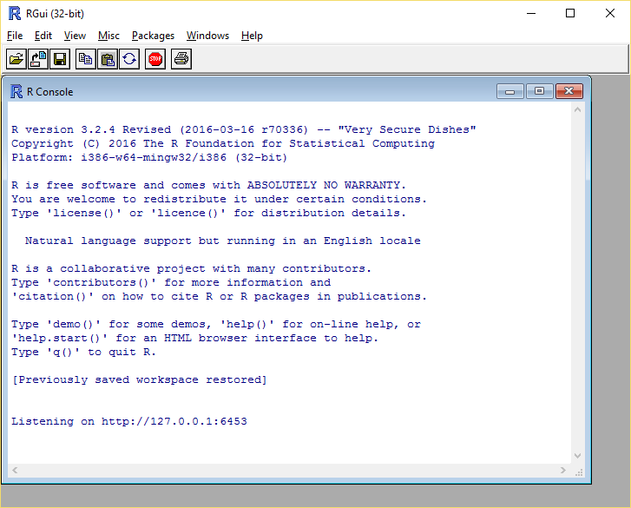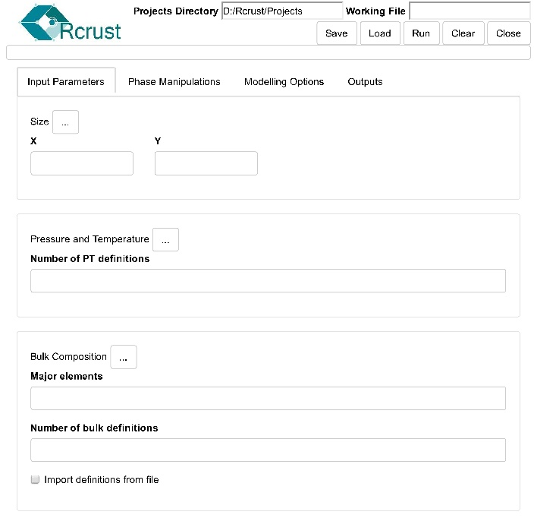

R Console

**Figure 7 -Rcrust GUI and R Console (blue). Highlighted are the positions of the Projects Directory (green), Working File (red) and Rcrust toolbar (black).**

1. **Type “Example1” into the text box on the right of Working File and then click the Load button from the Rcrust toolbar**

The data previously saved in the “Example1” file is now loaded into R and previously saved input parameters are loaded into the Rcrust GUI. To ensure that we do not overwrite any data lets rename the Working File.

1. **Rename Example1 by typing “Example\_simple” into the Working File textbox then click the Save button from the Rcrust toolbar**

This will save the current Rcrust GUI inputs into a new file named “Example\_simple”. The Rcrust GUI should now look similar to Figure 8.

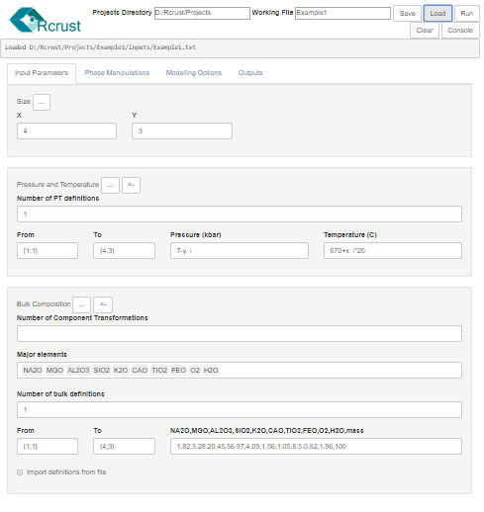

Size

Bulk Composition

Pressure and Temperature

**Figure 8 - Rcrust GUI with Example1 (Example\_simple) parameters loaded. The GUI consists of a number of tabs. The Input Parameters tab sets the size, P-T conditions and bulk composition (X) of the simulation.**

This example calculates the phases encountered at points in P-T-X space. Input parameters are grouped into collapsible panels:

* Size Panel

The **Size** panel sets the number of points in the simulation (here 4 points in the **X** direction multiplied by 3 in the **Y** direction). Points in the simulation space are identified by **tuples** written as {x\_i ; y\_i} where i denotes the current point.

Y

X

{x\_i ; y\_i} = {4 ; 3}

Figure 9 – Simulation space with point coordinates defined by tuples {x\_i ; y\_i}

* Pressure and Temperature Panel

Parameters in the simulation space are filled by a number of definitions. Each unique definition is applied over a range between the tuples **From** { x\_a ; y\_a } and **To** { x\_b ; y\_b } where a and b denote the start and end points of a rectangular range. Each definition sets its attributes as constants or as functions of the point’s position. **X** and **Y** positions of points are accessed by the variables x\_i and y\_i respectively. In the **Pressure and Temperature Panel** we set the Pressure in kilobars and Temperature in degrees Celsius for each point. In this example **Pressure** decreases along the y-axis by 1 kbar per point (7-y\_i) and **Temperature** increases along the x-axis by 20 °C per point (670+x\_i\*20).

* Bulk Composition Panel

The **bulk composition** of the system is made up of a number of major elements expressed as wt.% elemental oxides. For this simple example we define the bulk composition to be constant across the full P-T space, and we give it the value of the average amphibolite-facies pelite composition considered in (Mayne et al., 2016).

|  |  |  |  |  |  |  |  |  |  |  |
| --- | --- | --- | --- | --- | --- | --- | --- | --- | --- | --- |
|  | **Na2O** | **MgO** | **Al2O3** | **SiO2** | **K2O** | **CaO** | **TiO2** | **FeO** | **O2** | **H2O** |
| wt.% | 1.82 | 3.28 | 20.45 | 56.97 | 4.09 | 1.56 | 1.05 | 8.5 | 0.62 | 1.96 |

Table 1 – Average amphibolite facies pelite composition considered in (Mayne et al., 2016).

To get started let’s run a reconnaissance simulation:

1. **Click the Run button from the Rcrust toolbar**

This will save inputs in the Rcrust GUI and launch the calculation procedure into the R console. The R console should now have a few lines of text in it (like the figure below). If your simulation successfully initialized, then it will print out the “Initiation successful” message and begin the calculation (highlighted in red). If your console failed to initialize the program try reloading the original “Example1” file by closing Rcrust then starting from step 1 again, if problems persist try reinstalling Rcrust or report the problem to the developers (mjmayne@outlook.com). The calculation will run for 12 points :4 in the X direction by 3 in the Y direction. The results will automatically be saved to file and you will be prompted to select outputs.

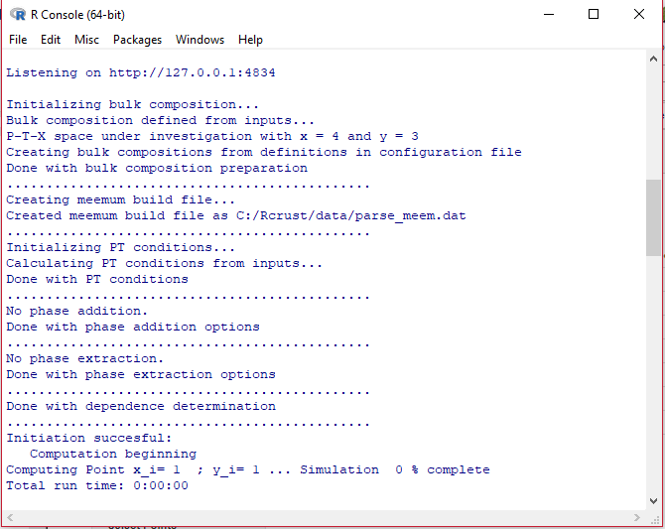

**Figure 10 - The Rcrust calculation is launched into the R Console if initiation is successful the message “Initiation successful” is printed and the calculation will begin.**

1. **Once the calculation is complete, navigate back to the Rcrust GUI and Select the Outputs tab**

Here we see a compilation data file for the points in our simulation. To compare points, click the “Select Output” drop down and choose “Grid”.

1. **Choose “Grid” under “Select Output”**

Grid allows easy comparisons between points for example choose:

* Select Output = Grid
  + Variable = wt% and Melt\_rs

1. **Choose Variable=“wt%” and ”Melt\_rs”**

The output should now match Figure 11. This shows us the amount of melt in the Reactive Subsystem (RS) over our point selection in P-T-X space. For further outputs you can deal directly with the data in the R console (hint: you can plot data directly into GCDkit). To access the data in R console, click the “Console” button on the Rcrust toolbar to launch a browser access. To return to the Rgui at any point type “c” then press [enter].

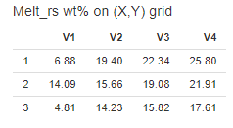

Figure 11 – Grid output Data for Example\_simple showing weight percentage of melt in the reactive subsystem for the P-T-X points selected

To view a graphical output of this data toggle the “View” selection to “Plot”. This will plot a filled contour graph of the selected data which can be saved directly as a .ps file through the “Save To File” button at the bottom of the selection panel.

1. **Toggle the “View” selection from “Data” to “Plot” and choose “Bottom Axis” as “Temperature”, “Left Axis” as “Pressure”**

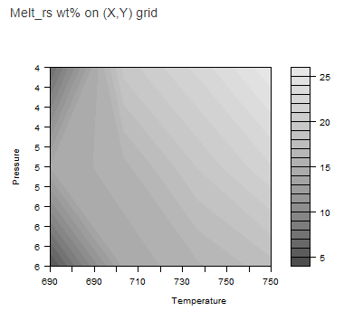

Figure 12 – Grid output Plot for Example\_simple showing weight percentage of melt in the reactive subsystem for the P-T-X points selected as a filled contour plot

Example2 – Phase extraction

Phase extractions can remove phases from the reactive subsystem. This is used to simulate scenarios such as melt loss or fractional crystallization.

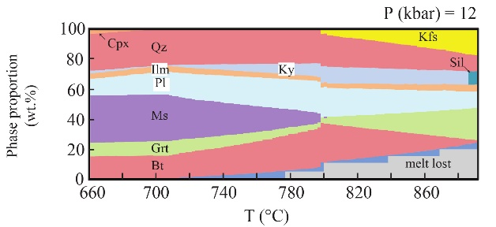

Figure 13 – Example of melt extraction along a P-T-X path from (Mayne et al., 2016): Weight percentage of phases verses temperature in degrees Celsius for a fixed pressure of 12 kbar. Starting composition taken as an average amphibolite facies pelite (Table 1). Melt is extracted whenever a 7 vol.% threshold is met.

Let’s perform melt extraction along a path in the P-T-X space explored by Example1.

1. **Load Example2 by opening Rcrust, typing ‘Example2’ in working file and clicking “Load”**

To ensure that we do not overwrite any data lets rename the Working File.

1. **Rename the file by typing “Example\_extract” into Working File then click the Save button from the Rcrust toolbar**

This will save the current Rcrust GUI inputs into a new file named “Example\_extract”. The Rcrust GUI should now look like the images below:

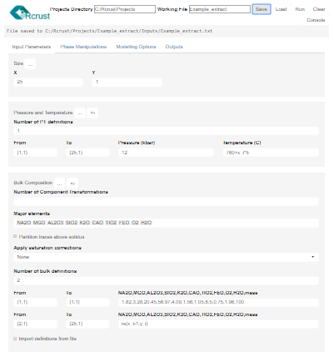

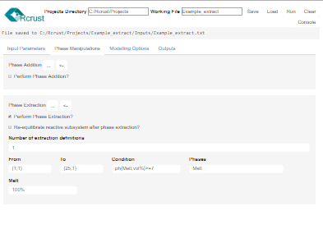

Figure 14 - Rcrust GUI inputs for Example\_extract

This example calculates an open system dependent path in P-T-X space. The bulk composition of the Reactive Subsystem is altered by phase manipulations encountered along the path. Phase Manipulations are grouped into collapsible panels:

* Phase Addition

Phases such as intruding fluids, segregated melts or residual crystals can be incorporated into the reactive subsystem. These additions are defined by the major elemental oxides chosen in “Bulk composition”.

* Phase Extraction

Phases in the reactive subsystem can be extracted when set conditions are met. These conditions are defined as logical arguments such as “TRUE”/”FALSE” to extract for every point/no points respectively. Alternatively a logical argument can be built of the form “phase,operand,value,unit” where phase = name of the phase/solution model, operand = (<,<=,==,>=,>,!=), value = a number and unit = the phase property to test. In this example we want to trigger extraction whenever a melt threshold is reached so our conditional argument is “Melt,>=,7,wt%”. Note that each argument in the condition is separated by a comma.

When the condition is met phase extraction is triggered on the reactive subsystem. For each phase listed in **Phases for Extraction** we need to define the amount of the phase to extract. This can be a numeric value (interpreted as mass relative to the starting mass defined in the Bulk Composition Panel), or a percentage of the current value. In this example we extract all melt (100%).

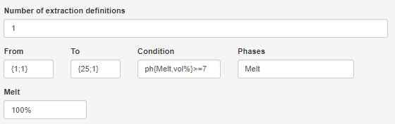

Figure 15 - Phase extraction definition for Example\_extract

To save you time we have pre-run this calculation so you can directly view the results by selecting the **Outputs** tab.

1. **Select the Outputs tab in the Rcrust GUI**

A custom output selection is available for viewing phase abundances along a path.

1. **Choose “Phase Abundance Along Path” under “Select Output”**

Here you can select which axis the path traverses (axis), which path you wish to consider (path), select the (Start Point) and (End Point) of the path and add a label for the column names.

1. **Set “End Point” as 25**

The output should now match Figure 16.

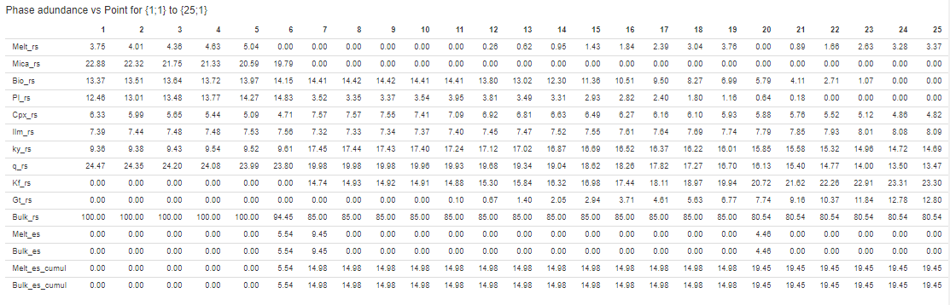

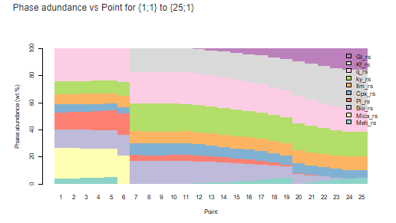

Figure 16 – Phase Abundance Along Path output for Example\_extract showing mass of each phase in the full system (FS) across the P-T-X points selected.

This output highlights a few key features of the phase extraction function:

* Outputs in the Phase Abundance along path plotter are expressed as wt.%
* The second melt extraction event extracts more than 7 vol.% melt (relative to the full system)(red box) even though the melt extraction threshold was set to be 7 vol.%

Reason -> Evaluations are only performed at each point thus if the resolution (number of points) is low then large changes can occur between each point.

* Subsequent melt extraction events may appear less than the melt extraction threshold (green boxes)

Reason -> The melt extraction threshold is evaluated relative to the Reactive Subsystem (which itself is shrinking due to melt extraction events) thus equivalent proportions of melt equate to different proportions when compared to the full system (FS).

Example3 - Multi-path functionality

Multiple paths can be compiled in P-T-X space to produce path-dependent P-T mode diagrams. In these diagrams a plane in P-T space is filled with points originating from dependent paths.

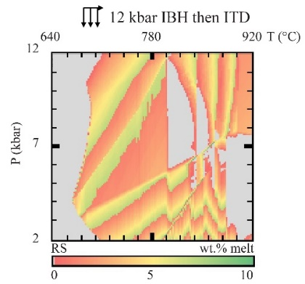

Figure 17 – Example of a composite path-dependent P-T mode diagram from (Mayne et al., 2016): Colours scale the weight percentage of melt in the reactive subsystem (RS). Starting composition at 640 °C and 12 kbar taken as an average amphibolite facies pelite (Table 1). Melt is extracted whenever a 7 wt.% threshold is met and leaves behind 1 wt.% approximating melt retention on grain boundaries. The simulation space is filled by a number of isothermal decompression paths that each originate off a 12 kbar isobaric heating path.

Let’s create a path-dependent P-T mode diagram by decompressing off of the path investigated in Example2.

1. **Load Example3 by opening Rcrust, typing ‘Example3’ in working file and clicking “Load”**

To ensure that we do not overwrite any data lets rename the Working File.

1. **Rename the file by typing “Example\_multi” into Working File then click the Save button from the Rcrust toolbar**

This will save the current Rcrust GUI inputs into a new file named “Example\_multi”. The Rcrust GUI should now look like Figure 18.

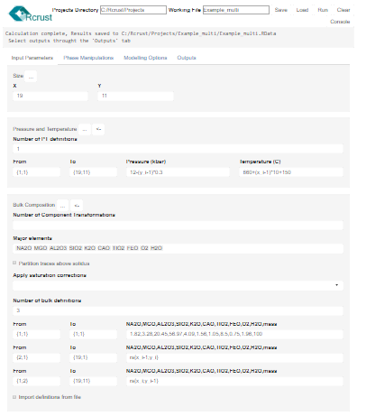

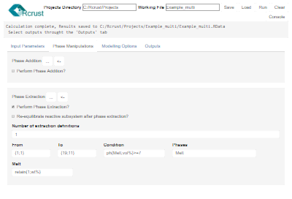

Figure 18 - Rcrust GUI inputs for Example\_multi

This example creates a composite path-dependent P-T mode diagram. It does this by first calculating an open system isobaric heating path at 12 kbar (IBH12) and then calculating a number of isothermal decompression paths that each originate from a point on IBH12. Points along IBH12 are each dependent on the reactive subsystem of the point one to the left of itself on the x-axis. Points along decompression paths are each dependent on the point one above itself on the y-axis. Melt loss is defined to occur whenever a 7 vol.% melt threshold is met and melt is extracted until 1 wt.% melt is left behind (this is achieved using the “retain(amount,unit)” function).

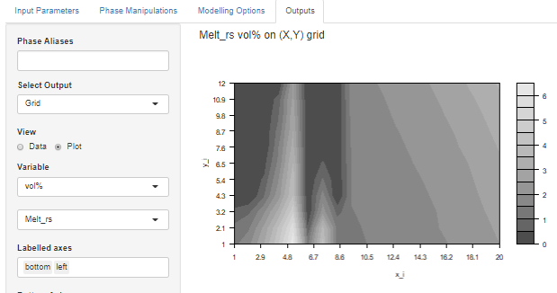

Figure 19 - Grid output for Example\_multi showing volume percent of melt in the reactive subsystem (RS)

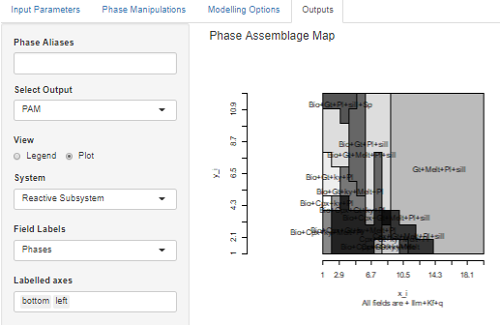

Figure 20 – Phase assemblage map for Example\_multi labelling fields by phase assemblage

REFERENCE MANUAL

Rcrust File Management

The top line of the Rcrust GUI hosts a toolbar of file management buttons. User inputs are saved in a text document (**Working File**) which is located in the Projects folder of Rcrust (**Projects Directory**). This file is written, read or run in Rcrust by the **Save**, **Load** and **Run** buttons.

Projects Directory

Rcrust Toolbar

Working File

Status

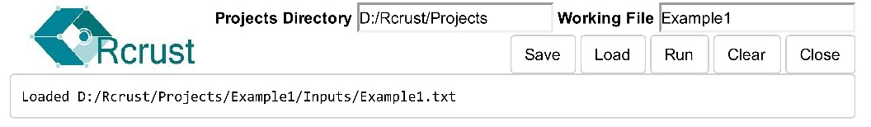

Save

Saves the **Working File’s** inputs and calculation results. Each working file is assigned its own project folder in the **Projects Directory**. Parameters currently in the Rcrust GUI are saved to the Inputs folder as a text document. Additional parameters can be passed to Rcrust by placing them in the text document after the line (# Additional Parameters). Calculation results are saved as an R workspace in the project folder.

Load

Loads the **Working File’s** inputs and calculation results. Reads the working file from the inputs folder and loads its options in the Rcrust GUI. Replaces the current workspace with that of the **Working File’s.**

Run

Saves the current Rcrust GUI inputs and runs the Rcrust calculation according to these parameters. Follow prompts in the R console to calculate the results. Once the results are complete you will be prompted to select outputs through the Rcrust GUI. Outputs written to file are saved in the Ouputs folder of the project Advanced users can access the results directly in the R console by pressing [esc] to activate the console (this is helpful for loading data into GCDkit). To relaunch the Rcrust GUI type 'runApp()' then press [Enter]

Clear

Clears current values in the Rcrust GUI

Console

Launches a browser in the R console giving you direct access to the coding environment and all calculated data

List of Parameters

User inputs are listed here in a systematic fashion for clarity. The parameter name (the name that appears in the Rcrust GUI) is listed first followed by the variable name (the name of the variable accessible in the R console). The data type required for the parameter is listed in the second box. The third box contains possible values for the parameter and identifies any default value. Below this is a description as to what the parameter controls.

**Parameter description**

**Default value**

**Parameter name**

**Data type**

**Possible values**

**Variable name**

|  |  |  |
| --- | --- | --- |
| **Example Parameter {ex\_par}** | Integer | 0 = closed  1 = open  Default = 0 |
| Example definition for the parameter | | |

Input Parameters

Tuple definitions

|  |  |  |  |  |
| --- | --- | --- | --- | --- |
| From  {pt\_from\_#} | |  | Tuple | {1;1}<= pt\_from\_#<={x\_n;y\_n} |
|  | The beginning of the definition selection | | | |

|  |  |  |
| --- | --- | --- |
| To  {pt\_to\_#} | Tuple | pt\_from\_#<=pt\_to\_#<={x\_n;y\_n} |
| The end of the definition selection | | |

Size

Specify here the size of the simulation (resolution) you want to calculate: how many points in the X and Y directions.

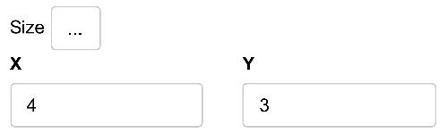

|  |  |  |
| --- | --- | --- |
| X  {x\_n} | Numeric | 1< x\_n |
| The total number of points in the X direction | | |

|  |  |  |
| --- | --- | --- |
| Y  {y\_n} | Numeric | 1< y\_n |
| The total number of points in the Y direction | | |

Pressure and Temperature

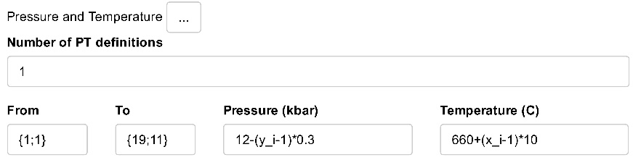

|  |  |  |
| --- | --- | --- |
| Number of PT definitions  {n\_pt\_def} | Numeric | 1< n\_pt\_def |
| The number of definitions to use for assigning pressure and temperature values | | |

|  |  |  |
| --- | --- | --- |
| Pressure (kbar)  {pressure\_#} | Numeric/Expression | 0<P |
| The pressure in kilobars of the Reactive Subsystem (RS). \*(1 kbar = 0.1 GPa = 986,92 atm).  This can be a constant or an expression built using the variables x\_i, y\_i, real numbers and Arithmetic Operators. e.g. 12-(y\_i-1)\*0.3 to decompress along the y-axis by 0.3kbar per step starting at 12 kbar. | | |

|  |  |  |
| --- | --- | --- |
| Temperature (°C)  {temperature\_#} | Numeric/Expression | 0<T |
| The temperature in degrees Celsius of the Reactive Subsystem (RS). \*(1 °C = 274.15 K = 33.8°F)  This can be a constant or an expression built using the variables x\_i, y\_i, real numbers and Arithmetic Operators. e.g. 660+(x\_i-1)\*50 to heat along the x-axis by 50°C per step starting at 660°C. | | |

|  |  |  |
| --- | --- | --- |
| PT definition  {pt\_def} | String | Options: input |
| Advanced setting toggling the PT definition mode. Used to allow PT definition from file. \*pt definition from file still to come | | |

|  |  |  |
| --- | --- | --- |
| {pt\_definitions} | Listed Definition |  |
| Pressure and temperature definitions of the form  pt\_definitions<-list("{x\_a,y\_a}\_{x\_b,y\_b}"=c("pressure\_#","temperature\_#"), "{x\_a,y\_a}\_{x\_b,y\_b}"=c("pressure\_#","temperature\_#")) | | |

|  |  |  |
| --- | --- | --- |
| Import PT from file button | Action | e.g. Import PT.csv |
| To import definitions into the GUI from a file click the left arrow at the top of the bulk composition panel. Click “Browse” to select the file from which conditions should be read and then click “Import” to write those definitions into the GUI. The file being read can be a “.txt” or “.csv” file and should have a format as follows. | | |

Additional Settings (main.r)

|  |  |  |
| --- | --- | --- |
| {PT\_restrictions} | Comma-separated-strings |  |
| P-T conditions which should not be calculated. Use if projecting array through array where points should be ignored | | |

Bulk composition

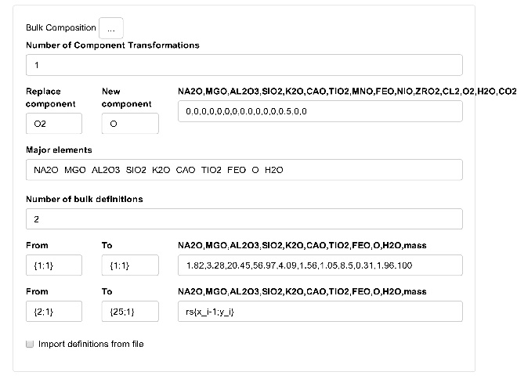

|  |  |  |
| --- | --- | --- |
| Number of Component Transformations  {n\_comp\_trans} | Numeric | 0<= n\_comp\_trans |
| The number of component transformations to apply to the currently available chemical components: the possible components for transformation are set by the thermodynamic data file | | |

|  |  |  |
| --- | --- | --- |
| Replace component  {old\_comp\_#} | String |  |
| The current component to replace | | |

|  |  |  |
| --- | --- | --- |
| New component  {new\_comp\_#} | String | <6 characters, All capitals |
| The name of the new component. This name must consist of less than 6 characters and must be all in capital letters. | | |

|  |  |  |
| --- | --- | --- |
| NA2O,MGO,...  {comp\_#} | Comma-separated numeric |  |
| The value of the new component as a factor of the available components:. This must be a string of comma separated numbers of which a total of no-more-than 11 can be non-zero. For example, if we wish to use the component O instead of O2 and our starting chemical components are NA2O,MGO,AL2O3,SIO2,K2O,CAO,TIO2,MNO,FEO,NIO,ZRO2,CL2,02,H2O,C02 we would use: 0,0,0,0,0,0,0,0,0,0,0,0,0.5,0,0 If we wish to use FE2O3 we would use:  0,0,0,0,0,0,0,0,2,0,0,0,0.5,0,0 | | |

|  |  |  |
| --- | --- | --- |
| Major elements  {major\_elements} | Comma-separated-strings |  |
| The major element components used to define the bulk composition. | | |

|  |  |  |
| --- | --- | --- |
| Number of bulk definitions  {n\_bulk\_def} | Numeric | 1<= n\_bulk\_def |
| The number of definitions to use for assigning bulk compositional values. | | |

|  |  |  |
| --- | --- | --- |
| NA2O,MGO,...,mass | Comma-separated-values/expressions | e.g. 1.5, 20.2, 40.8, 100  e.g. rs{x\_i-1;y\_i} |
| The wt.% of each elemental oxide listed in “Major elements” (above) as well as the relative starting mass (in grams) of the Reactive Subsystem (RS).  Expressions can use real numbers, Arithmetic Operators, x\_i, y\_i, x\_n, y\_n and any tuples of the form xs{#;#} where xs is any of rs,as,es,fs and # uses real numbers, Arithmetic Operators , x\_i, y\_i, x\_n and/or y\_n  If xs{#;#} is of length 1 it will be repeated to fill the required terms.  i.e. To make the full bulk composition of one point dependent on another first initialise the starting composition and then set the dependent points as rs{x\_i-1; y\_i} for dependence on the x-axis or rs{x\_i ; y\_i-1} for dependence on the y-axis | | |

|  |  |  |
| --- | --- | --- |
| Import definitions from file  {bulk\_def\_file} | Boolean | TRUE = Import from file  FALSE = definition via input |
| Choose whether bulk definitions are read from input or imported from a text file (.txt) located in the Inputs folder. | | |

|  |  |  |
| --- | --- | --- |
| Bulk file  {bulk\_file} | Character string | e.g. bulk.txt |
| The name of the input file containing the bulk composition definitions (the name must end with .txt). The bulk file must be a tab delimited text file (.txt) containing the columns “From”, “To”, your selection of major elements and “Mass”. For example:    This text file can be easily exported from an excel file using File\Save As\Text (tab delimited) (\*.txt)    The input file must provide bulk definitions for all points in the chosen modelling space {x\_n;y\_n} with numbers in the “from” and “to” arguments separated by a semicolon (;). Note: pay attention to the capitalisation from, to and mass are all lower case. The from and to vector do not have curly brackets.  The bulk definitions describe the wt.% of each elemental oxide as well as the relative starting mass (in grams) of the Reactive Subsystem (RS). Expressions can use real numbers, r operators, x\_i, y\_i, x\_n, y\_n and any tuples of the form xs{#;#} where xs is any of rs,as,es,fs and # uses real numbers, r operators, x\_i, y\_i, x\_n and/or y\_n | | |

|  |  |  |
| --- | --- | --- |
| Import bulk from file button | Action | e.g. Import bulk.csv |
| To import definitions into the GUI from a file click the left arrow at the top of the bulk composition panel. Click “Browse” to select the file from which conditions should be read and then click “Import” to write those definitions into the GUI. The file being read can be a “.txt” or “.csv” file and should have a format as follows. Note: the file simply reads in the definitions so make sure that you have set the correct number of major elements etc. as these are sourced from the GUI not the file. | | |

Phase Manipulations

Phase Addition

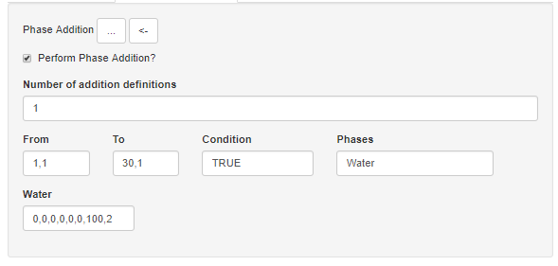

|  |  |  |
| --- | --- | --- |
| Perform Phase Addition?  {ph\_add} | Boolean | TRUE/FALSE |
| Add phases/components into the Reactive Subsystem (RS) at specified points? | | |

|  |  |  |
| --- | --- | --- |
| Number of addition definitions  {n\_ph\_add\_def} | Numeric |  |
| The number of definitions to use for assigning phase additions. | | |

|  |  |  |
| --- | --- | --- |
| Condition  {ph\_add\_con\_#} | Logical/expression | Options:  TRUE  FALSE  ph{Melt,vol%}>=7 |
| A conditional argument that evaluates to a Boolean answer of TRUE or FALSE.  Note: if directly providing argument as TRUE or FALSE ensure all capitals.  For example to add phases whenever melt exceeds a 7 vol% threshold you would use the following condition: ph{Melt,vol%}>=7 if “Melt” is the alias assigned in the solution model file used | | |

|  |  |  |
| --- | --- | --- |
| Phases for addition  {ph\_add\_phs\_#} | Comma-separated-strings |  |
| Phases to be considered for phase addition in each definition. This can be any name as it is only the respective chemical components that are added to the system not the phase itself, thus the phase name is just a place holder for the user to remember what they are adding. | | |

|  |  |  |
| --- | --- | --- |
| #,#,mass | Comma-separated-values |  |
| The wt.% of each elemental oxide listed in “Major elements” (Bulk composition tab) as well as the relative mass (in grams) of the phases/components to add. | | |

Phase Extraction

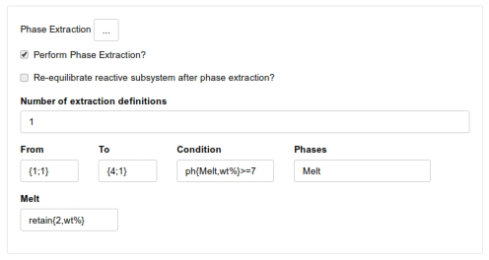

|  |  |  |
| --- | --- | --- |
| Perform Phase Extraction?  {ph\_extr} | Boolean | TRUE/FALSE |
| Extract phases from the Reactive Subsystem (RS) when specified criteria are met? | | |

|  |  |  |
| --- | --- | --- |
| Re-equilibrate reactive subsystem after phase extraction? {reequilibrate\_steps} | Boolean | TRUE/FALSE |
| Use the bulk composition at the end of extraction to recalculate phase stabilities | | |

|  |  |  |
| --- | --- | --- |
| Number of extraction definitions  {n\_ph\_extr\_def} | Numeric |  |
| The number of definitions to use for assigning phase extractions. | | |

|  |  |  |
| --- | --- | --- |
| Condition  {ph\_extr\_con\_#} | Logical/expression | Options:  TRUE  FALSE  ph{Melt,vol%}>=7 |
| A conditional argument that evaluates to a Boolean answer of TRUE or FALSE.  Note: if directly providing argument as TRUE or FALSE ensure all capitals.  Expressions should be of the form described in “Extraction expressions” below.  For example to extract phases whenever melt exceeds a 7 vol% threshold you would use the following condition: ph{Melt,vol%}>=7 if “Melt” is the alias assigned in the solution model file used | | |

|  |  |  |
| --- | --- | --- |
| Phases for extraction  {ph\_extr\_phs\_#} | Comma-separated-strings |  |
| Phases to be considered for phase extraction in each definition. These can be any alias in the solution model file chosen (Phase Models tab) or any pure phase output by Perple\_X (see Perple\_X  http://www.perplex.ethz.ch/  Perple\_X Solution Model Glossary) and THERMOCALC’s list of mineral abbreviations).  \*Can use “any\_phase” to set generic arguments | | |

|  |  |  |
| --- | --- | --- |
| [Phase extraction proportions]  {ph\_extr\_phs\_*#*\_*phase*} | Numeric / percentage / expression | e.g.  10%  5 (mass relative to a starting mass of 100 for the full system)  retain{2;vol%;Melt}  delta{Melt ; x\_i-1 ; y\_i ; mass}\*0.5 |
| Define the proportion of phase to extract for each phase listed in “Phases for extraction”. Proportions can be given as:   1. A percentage of what is present (e.g. 10%) \*you must include the percentage sign for this   or   1. A set mass relative to the full system (100). If this amount is larger than what is present the full amount of the present phase will be extracted.   or   1. As functions of the form described in “Extraction expressions” below.   \*Can use “any\_phase” to set generic arguments for all phases that are present but don’t already have a phase extraction proportion set i.e. pre existing definitions take precedence. | | |

|  |  |  |
| --- | --- | --- |
| Extraction expressions | Numeric / percentage / expression |  |
| Extraction expressions can be evaluated for conditions or proportions consisting of x\_i, y\_i, real numbers, Arithmetic Operators, Logical Operators, {} and (). where {} separate terms for calculation order and () are reserved for solution model names.  The following functions can be called by placing the function name before {} with function terms inside the brackets separated by commas (,) or semi-colons (;).   * retain{amount ; unit ; phase}   + Retention extracts all but a set amount of a phase from the reactive subsystem where unit can be “mass”,”wt%” or “vol%”. In phase proportion boxes can omit “phase” to extract current phase.   + e.g. retain{2;vol%;Melt} will extract melt from the reactive subsystem until 2 vol% of melt remains, this is useful for approximating melt retention on grain boundaries. This can also be written as retain{2;vol%}   + \*Warning: when utilising multiple phase extraction definitions ensure that the retention definition is last in order to retain to the finalised bulk. * delta{phase ; x\_a ; y\_a ; unit}   + Delta calculates the incremental difference of a phase between the current point (point b) and a previous point (point a) such that:   delta=phase\_modeb - phase\_modea.  \*point a may be described as “prev\_ext\_X” where X is the name of any phase or “prev\_ext” to use the name of the extracting phase as default   * + phase = phase for extraction ; x\_a and y\_a describe the position of the previous calculated point and unit is one of “mass” or “wt%”.   \*phase may be described with “+” separating individual phase terms e.g. to calculate deltas for the alumina silicates phase would be “ky+and+sill”   * + e.g. delta{Melt ; x\_i-1 ; y\_i ; mass}\*0.5 to extract half of the delta mass for Melt when paths progress with increasing x\_i values. * ph{phase;unit;x\_i;y\_i}   + returns the requested variable (unit) for the given phase in the reactive subsystem. Where unit can be any column name in calc\_phases and x\_i and y\_i are the current point by default, if ph{} is only given two arguments the current point will be evaluated by default. | | |

Modelling Options

Modelling Data

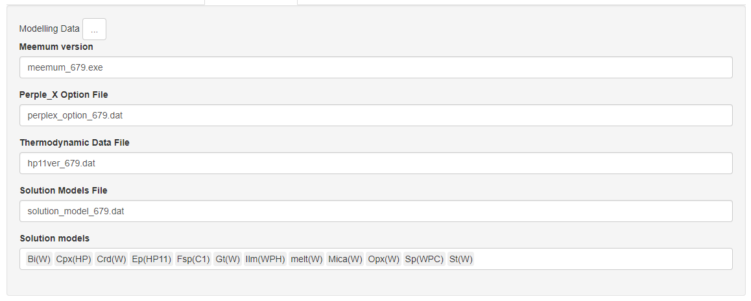

|  |  |  |
| --- | --- | --- |
| Meemum version  {meemum\_path} | String | Example = meemum.exe |
| The name of the meemum executable to be used in ~Rcrust/data for phase stability calculations. | | |

|  |  |  |
| --- | --- | --- |
| Perple\_X Option File  {perplex\_option\_file} | Strings | Example = perplex\_option.dat |
| The perplex option file present in ~Rcrust/data which controls extra settings for phase stability calculations. | | |

|  |  |  |
| --- | --- | --- |
| Thermodynamic Data File  {thermodynamic\_data\_file} | String | Example = hp11ver.dat |
| The thermodynamic data file present in ~Rcrust/data to be used for phase stability calculations. | | |

|  |  |  |
| --- | --- | --- |
| Solution Models File  {solution\_models\_file} | String | Example = solution\_model\_673.dat |
| The solution model file present in ~Rcrust/data from which solution models can be chosen. | | |

|  |  |  |
| --- | --- | --- |
| Solution models  {use\_sol\_models} | Comma-separated-strings |  |
| The solution models to use in phase stability calculations sourced from the Solution Models File.  (see Perple\_X  http://www.perplex.ethz.ch/  Perple\_X Solution Model Glossary) | | |

Additional optional parameters

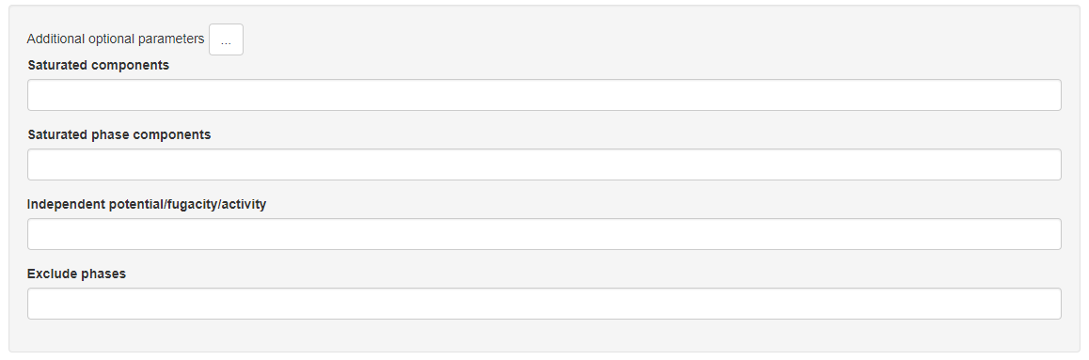

|  |  |  |
| --- | --- | --- |
| Saturated components  {saturated\_components} | String |  |
| Set saturated components | | |

|  |  |  |
| --- | --- | --- |
| Saturated phase components  {saturated\_phase\_components} | String |  |
| Set saturated phase components | | |

|  |  |  |
| --- | --- | --- |
| Independent potential/fugacity/activity  {independent\_potential\_fugacity\_activity} | String |  |
| Set independent potentials fugacities or activities | | |

|  |  |  |
| --- | --- | --- |
| Exclude phases  {exclude\_phases} | String |  |
| Set phases to be excluded from consideration during Gibbs energy minimisation | | |

Extra Settings

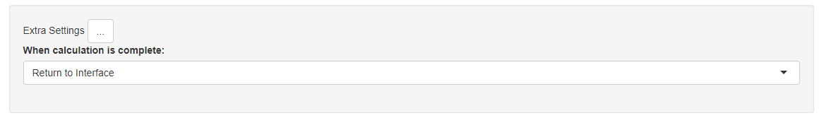

|  |  |  |
| --- | --- | --- |
| When calculation is complete:  {end\_of\_calc} | String | Options:  Return to interface  Logout  Shutdown  Default = Return to interface |
| Action to be performed when a calculation is complete. | | |

Outputs

|  |  |  |
| --- | --- | --- |
| Phase Aliases  { phase\_aliases} | Comma separated strings | e.g. TiBio(HP)=Bt,Gt(WPH)=Gt |
| A list of aliases to use for renaming phases of the form TiBio(HP)=Bt,Gt(WPH)=Gt,etc.  To hide a phase from plotting use the alias “hide” e.g. TiBio(HP)=hide.  To merge phases use “&” e.g. and&sill&ky=als or Bio(W)\_1&Bio(W)\_2=Bio | | |

Select Output = Data File

View the output data as a single filtered table

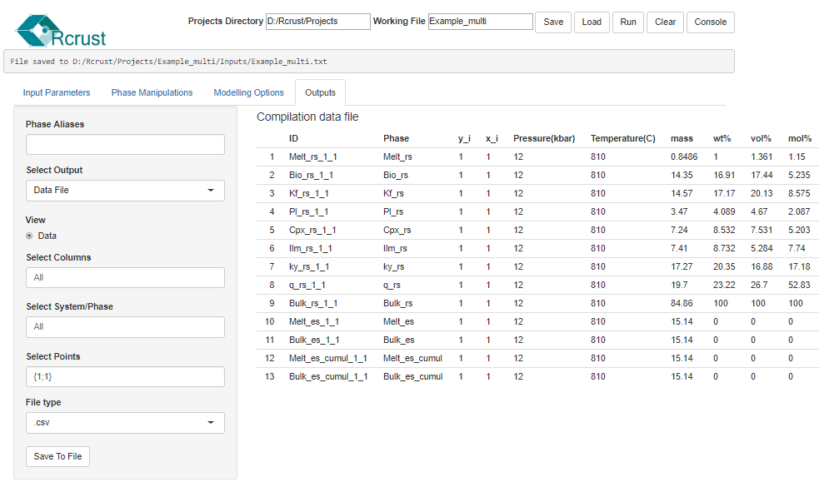

Select Output = Grid

View the output data by selecting a single variable to express on a grid of x\_i and y\_i coordinates. Contour plotting can be achieved by selecting View>Plot.

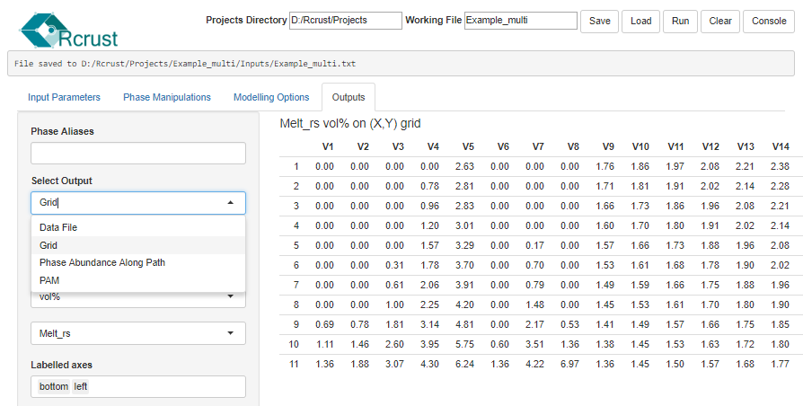

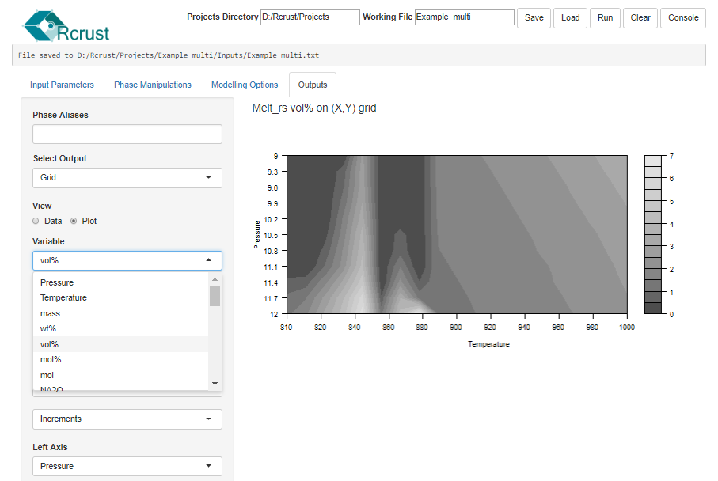

Select Output = Phase Abundance Along Path

View phase abundance data by weight along a path in the x or y direction.

Phase abundance graphs can be viewed as 100% stacked column graphs by selecting View>Plot

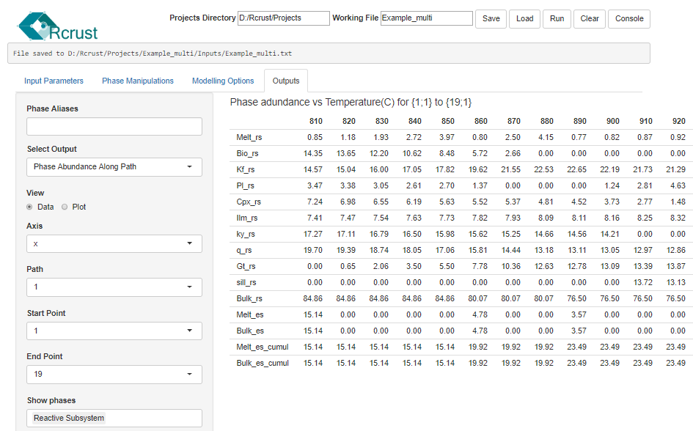 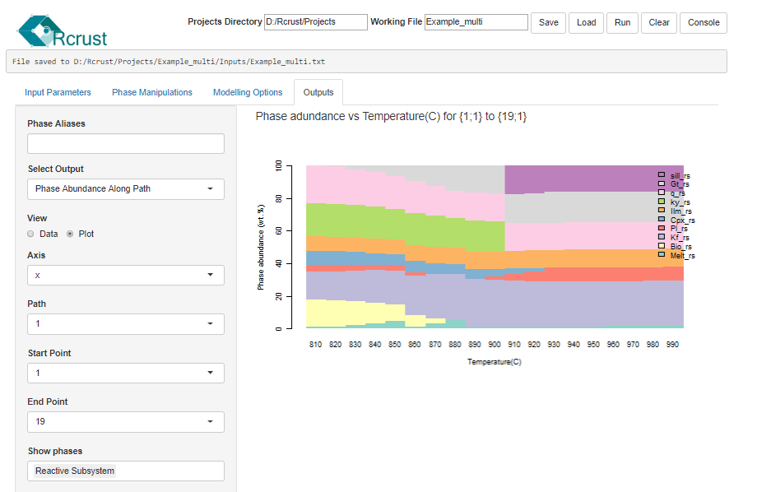

Select Output = PAM

Create a phase assemblage map by merging fields in x-y space with identical assemblages.

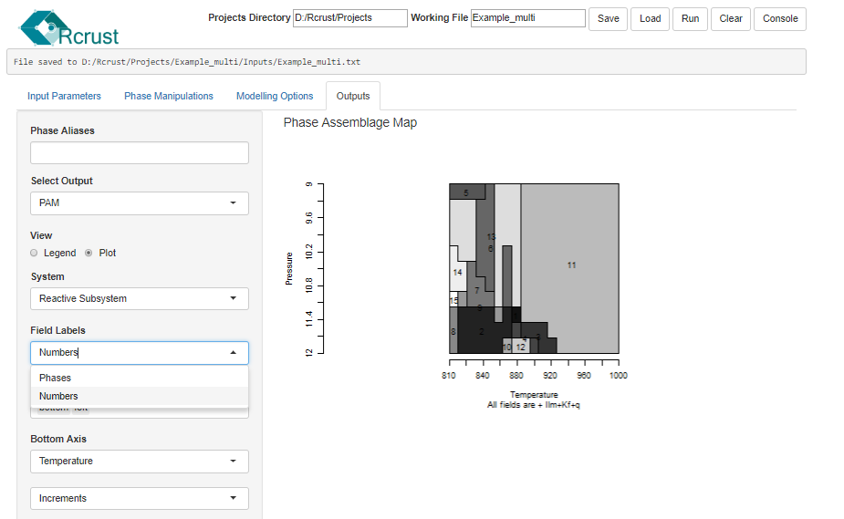

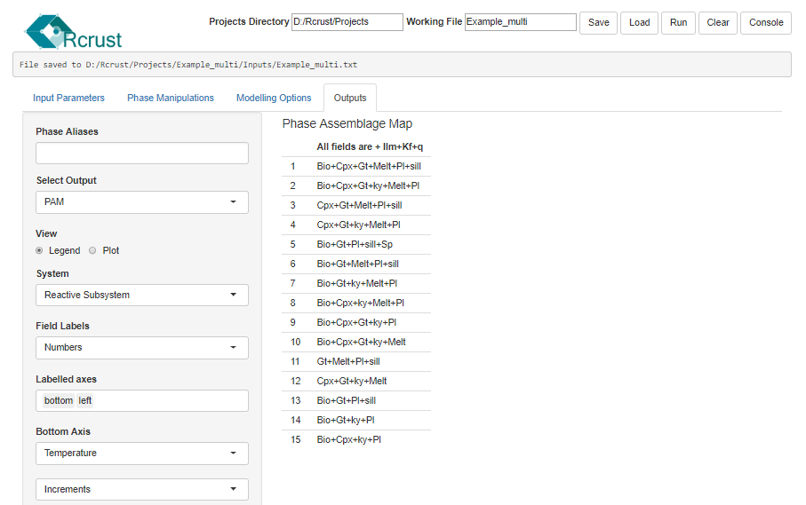

File Management

Functions for file management. See Rcrust File management for more details

|  |  |  |
| --- | --- | --- |
| Projects Directory  {projects\_directory} | String |  |
| Absolute location of the projects directory within the Rcrust folder. | | |

|  |  |  |
| --- | --- | --- |
| Working File  {working\_file} | String |  |
| Name of the current file under operation. Each file has its own folder within the projects directory containing results of simulations (#.RData file), “Inputs” and “Outputs”. | | |

|  |  |  |
| --- | --- | --- |
| Save  {on\_save} | Function call |  |
| Saves the current GUI inputs and workspace to the working\_file. | | |

|  |  |  |
| --- | --- | --- |
| Load  {on\_load} | Function call |  |
| Loads the previously saved working\_file into the GUI inputs and workspace. | | |

|  |  |  |
| --- | --- | --- |
| Run  {manual\_load} | Function call |  |
| Saves the current GUI inputs and workspace to the working\_file. Then launches the Rcrust calculation | | |

|  |  |  |
| --- | --- | --- |
| Clear  {on\_clear} | Function call |  |
| Clears the current GUI inputs and workspace. | | |

|  |  |  |
| --- | --- | --- |
| Console  {stopApp} | Function call |  |
| Closes the current GUI to allow interaction with the R console. To relaunch the Rcrust GUI type 'runApp()' then press [Enter]. | | |

Perple\_x options

Options parsed to wrapper calculation set in init\_meem.r

|  |  |  |
| --- | --- | --- |
| **Number of chemical components {number\_components}** | Integer | Default = 15 |
| The number of chemical components to build the major elements from. | | |

|  |  |  |
| --- | --- | --- |
| **Unit for bulk composition definition** | Integer | 0 = molar %  1 = weight %  Default = 1 |
| The unit proportion to use for bulk composition definition. | | |

Advanced user options

Static variable options accessible through main.r

|  |  |  |
| --- | --- | --- |
| **Calculation mode {calc\_mode}** | Character vector | normal  Default = normal |
| Advanced setting toggling the calculation mode. | | |

|  |  |  |
| --- | --- | --- |
| **Reaction buffering {reaction\_buffering}** | Boolean | T (TRUE)  F (FALSE)  Default = FALSE |
| Allows reaction buffering (threshold buffering) whereby phase extractions set on conditions are postponed by the number of reaction buffer steps to ensure continued exceedance of the threshold. | | |

Useful functions in the R Console

c Continue steps in a browser (if accessed by clicking “Console” in the Rcrust GUI then closes the browser and returns to the Rcrust GUI)

ls() List all objects in the current environment

ls(envir=.GlobalEnv) List all objects in the global environment

Q() Quits the current session

[Ctrl]+[w] Toggles buffering of outputs

**Rcrust()** Manually launches the Rcrust GUI

To access the R console out of a browser click anywhere in the R console window and press [esc]. This will close the Rcrust GUI which has current control over the console. To relaunch the Rcrust GUI at any time simply type runApp() and press [enter].

Rcrust variables

|  |  |
| --- | --- |
| **PT[[bulk]][[step]]$press$temp** | list |
| List of pressure and temperature conditions for each step in each bulk | |

|  |  |
| --- | --- |
| **crust[[bulk]][[step]][phase,detail]** | list |
| The full system (FS). Contains details of the reactive subsystem (RS) at each step along with cumulative extract (ES) and addition (AS) subsystems. Phases in crust are reported as cumulative weighted averages. | |

|  |  |
| --- | --- |
| **c0[detail]** | vector |
| Bulk composition passed between points | |

|  |  |
| --- | --- |
| **workingfile** | Character vector |
| The current Working File | |

|  |  |
| --- | --- |
| **work\_dir** | Character vector |
| The current Working Directory. This is the location of the folder containing the Working File | |

Running Rcrust

|  |  |  |
| --- | --- | --- |
| Relaunch GUI  {.First()} or {Rcrust()} | Function call |  |
| Relaunches the Rcrust GUI from the R console | | |

|  |  |  |
| --- | --- | --- |
| Manually initiate calculation  {manual\_load} | Function call |  |
| Sends the current working file to be calculated | | |

Rcrust Outputs

|  |  |  |
| --- | --- | --- |
| Data file  {data\_file()} | Function call |  |
| Compiles calculation results into a table | | |

|  |  |  |
| --- | --- | --- |
| Write data file  {write\_data\_file} | Function call |  |
| Writes compilation table to file | | |

|  |  |  |
| --- | --- | --- |
| Grid data  {grid\_data()} | Function call |  |
| Compiles an X Y grid of the values of a given variable | | |

|  |  |  |
| --- | --- | --- |
| Write grid file  {write\_grid\_file} | Function call |  |
| Writes X Y grid to file | | |

R Syntax

|  |  |  |
| --- | --- | --- |
| Arithmetic Operators |  |  |
|  | | |

|  |  |  |
| --- | --- | --- |
| Logical Operators |  |  |
|  | | |

Development

Developers of new features should know a few things on the structure of the code. When developing custom functions please stick to these conventions.

The following files are required; they must all be in the same directory (these are contained within the Rcrust folder which should simply be copied to the desired location):

1. From **Perple\_X** suite (in the folder called “data”):
   1. The various datafiles you wish to use, these include: thermodynamic datafiles and solution model files, typically *hp04ver.dat* and *solution\_model.dat* as well as the Perple\_X option file, *perplex\_option.dat*.
   2. Meemum.exe
   3. The rest of Perple\_X (vertex, build, werami, etc.) are not required.
2. From **Rcrust** (in the folder called “code”):
   1. ui.r and server.r, these build the Rcrust Graphical User Interface (GUI)
   2. *main.r*, this houses the main calls to run Rcrust
   3. *meemum\_connect.r,* the functions for calling and interpreting outputs from meemum
   4. Various init\_xxx files, used to transform user input in data structures that Rcrust can understand.
      1. *init\_bulk.r* sets the bulk composition(s) of the system
      2. *init\_pt.r* sets the *P–T* conditions
      3. *init\_ph\_add.r* sets the phases to add
      4. *init\_ph\_extr.r* sets the phases to extract
      5. *init\_meem.r* writes user inputs into a meemum build file
      6. *init\_dependence* determines the calculation order of points
      7. *init\_wrapper* the phase stability calculator from Perple\_X
   5. *parse\_meem*, a temporary Perple\_X build file created to pass data into the wrapper
   6. *run.Rcrust.r*, the Rcrust calculation loop to be called for each point

Technically, each function works c0 which tracks the bulk compositional changes invoked by phase manipulations. main.r loops through each point, calculating and modifying the phases according to the chosen definitions and eventually stores the final product in a list called crust, whose structure is crust[[y\_i]][[x\_i]]. So, for instance the SiO2 content in the melt of point y\_i=4 and x\_i=2 is crust[[4]][[2]][“melt(HP)”,”SIO2”]

* 1. Various *xxx.dll* files which contain compiled libraries needed to perform calculations within R

Troubleshooting

A list of known errors that are unavoidable or are still to be fixed.

Bulk\_ss system properties

Warning: some bulk system properties are reported as molar properties but perplex considers the bulk system to be one mol thus all molar properties need to be adjusted accordingly

Molar phase proportions

Only weight definitions of bulk and phases is currently possible, read.meemum cannot read molar phase proportions. If molar proportions for bulk are entered, then bulk is molar but individual phases are weights thus phase extractions crash.

Buffered Output

The R console by default returns a buffered output which forces the console to only refresh when flush.console() is called. To disable the buffering and view run data live deselect from R toolbar Misc/Buffered Output.

External Sources

##### Perple\_X

##### <http://www.perplex.ethz.ch/>

##### Perple\_X Solution Model Glossary

<http://www.perplex.ethz.ch/PerpleX_solution_model_glossary.html>

##### THERMOCALC’s list of mineral abbreviations

<http://www.metamorph.geo.uni-mainz.de/thermocalc/documentation/abbreviations/index.html>

REFERENCES

Mayne, M. J., Moyen, J. F., Stevens, G., & Kaislaniemi, L. (2016). Rcrust: a tool for calculating path‐dependent open system processes and application to melt loss. *Journal of Metamorphic Geology*, **34**(7), 663-682

Connolly, J.A.D., 2005. Computation of phase equilibria by linear programming: a tool for geodynamic modeling and its application to subduction zone decarbonation. Earth and Planetary Science Letters, **236**, 524–541.

Connolly, J.A.D., 2009. The geodynamic equation of state: what and how. Geochemistry, Geophysics, Geosystems, **10**, 1–19.

Connolly, J.A.D. & Kerrick, D.M., 1987. An algorithm and computer program for calculating composition phase diagrams. Calphad, **11**, 1–55.